**A Project Report on**

**BLOOD DONOR WEBSITE**

**USING HTML & CSS**

submitted by

**V NOSHITHA NAVYA RENUKA - GQT-S0156**

under the mentorship of

**KESHAV MURTHY**



**GLOBAL QUEST TECHNOLOGIES**

[info@gqtech.in](mailto:info@gqtech.in)

Yelahanka Satellite Town,

Bangalore, Karnataka - 560064.

[2023]

**Signature of the mentor Signature**

**Keshav Murthy G.R.Narendra Reddy**

**INTRODUCTION**

**HISTORY OF HTML:**

**HTML** stands for **Hyper Text Markup Language**.

* It is used to share the information over the internet.
* HTML id developed by Tim Berner’s Lee in 1991.But officially in 1993.
* The First version of HTML consists of “18 tags”
* HTML follows certain rules and regulations setup by “**ISO**”.
* International Organization for standardization is set of rules and regulation are present in ‘**SGML**’ document.

**Versions of HTML**

* **HTML-1** version in the year 1993.
* **Html-2** version in the year 1995.
* **HTML-3.02** version in the year 1997.
* **HTML-4.1** version in the year 1999.
* **HTML-5** version in the year 2014.

**Features of HTML**

* It is easy to Learn.
* It is a tag based language.
* HTML is supported by multiple browsers.
* First web browser is Netscape navigation which was developed by the “Mosiac”.
* It is a portable language.
* **WORA** stands for ‘write once run anywhere’

**Limitation of HTML**

* HTML has less designing capabilities.
* It is dependent on other technology such as CSS in order to develop well designed Webpages.
* HTML has no programming capabilities.
* Using HTML and CSS we can develop only static Web page.
* In order to write the HTML code required an editor such as VS Code, Notepad, Eclipse.
* In order to execute the HTML code we required Web browsers.Like Chrome, Firefox, edge, Opera Safari .

**CSS**

* **CSS** stands for **Cascading Style Sheets**.
* It was developed by W3C to add stylings to the HTML elements.
* W3C stands for World Wide Web.com

**Versions of CSS:**

* CSS-1 (level-1) in the year 1996.
* CSS-2 (level-2) in the year 1998.
* CSS-3 (level-3) in the year 1999.

**Why do we required CSS ?**

* Since HTML has less designing capabilities we cannot create well designed or most appealing Websites.
* Using HTML we cannot add style, animation and transitions to the Webpage.
* Therefore we require CSS to create well designed Webpages.

**Advantages of CSS**

* It allows to add styles, animation and variouses effects to the Webpage.
* It allows us to develop the Webpage rapidly. It is also know as RAD ( rapid application Developer).
* It allows us to separate from formatting develop page to the presentation of Webpage.
* It allows to create well designed Websites.

**Limitations of CSS**

* Using CSS we can perform static styles for the Webpages.
* In order to create dynamic styling for the Websites. We must make use of scripting language such as JavaScript and Libraries of JavaScript.

**Types of CSS:**

1. Inline CSS
2. Internal CSS
3. External CSS
4. Default Browser CSS

**Inline CSS:**

Defining all the CSS properties within the style attribute inside the opening of the tag is referred to as Inline CSS.

**Internal CSS:**

Defining all the CSS properties within <style> inside the HTML document is referred to as Internal CSS.

**External CSS:**

Defining all the CSS properties within as external Script or File with an extension CSS is referred to as External CSS.

* In order to link external CSS file within the HTML document we must use of <link>.
* The value for the ‘ref’ attribute should be ‘stylesheet’.

**BLOOD DONOR WEBSITE**

**Scope of the document**

Creating a blood donor website can be a valuable and potentially life-saving endeavor. The scope of such a website can be broad, encompassing various features and functionalities to ensure its effectiveness and user-friendliness. Here's a comprehensive scope for a blood donor website:

**User Registration and Profiles:**

* User registration and login functionality.
* User profiles with personal details (name, contact information, blood type, etc.).

**Donor Search and Matching:**

* Search functionality to find donors by location, blood type, and availability.
* Matching algorithms to connect donors with potential recipients.

**Donor Registration:**

* Donor registration forms with detailed medical history and eligibility criteria.
* Verification of donor information.

**Request Blood:**

* Request blood donations for specific cases (urgent and non-urgent).
* Form to provide details about the recipient's condition and blood requirements.

**Real-time Availability:**

* Real-time updates on donor availability.
* Push notifications or SMS alerts for urgent requests.

**Appointment Booking:**

* Integration with a calendar system for scheduling blood donation appointments.
* Notifications and reminders for appointments.

**Donor Management:**

* Donor database management.
* Ability to track donor eligibility and donation history.

**Blood Banks and Hospitals Integration:**

* Integration with local blood banks and hospitals to coordinate supply and demand.

**Health Records and Blood Test Results:**

* Feature for donors to upload and manage their health records and blood test results.

**Educational Resources:**

* Information on the importance of blood donation.
* Educational materials on blood types and compatibility.

**Community and Social Features:**

* Donor and recipient forums or chatrooms.
* Social sharing of donation stories and achievements.

**Privacy and Security:**

* Robust data security measures to protect user information.
* Privacy settings for users to control the visibility of their information.

**Donation Drives and Events:**

* Information on local blood donation events and campaigns.
* Ability to organize and promote donation drives.

**Feedback and Ratings:**

* Feedback system to rate donors and recipients.
* User reviews to build trust within the community.

**Mobile Compatibility:**

* A mobile-responsive design or dedicated mobile app for easy access.

**Administrative Dashboard:**

* Admin panel for managing users, donations, and site content.
* Moderation tools to ensure the integrity of the platform.

**Analytics and Reporting:**

* Data analytics to track user activity, donation trends, and website performance.

**Legal and Ethical Considerations:**

* Compliance with local and international blood donation regulations and standards.

**Marketing and Outreach:**

* Strategies to promote the website and attract donors and recipients.

**Continuous Improvement:**

* Regular updates and improvements based on user feedback and changing needs.

It's crucial to collaborate with healthcare professionals and blood donation organizations to ensure the website aligns with best practices and ethical standards in blood donation. Additionally, user education and community building should be ongoing efforts to encourage regular donations and engagement.

**Technologies Used**

* HTML5
* CSS3

**Our Project**

**Root Structure:**

**BLOOD DONOR**

**→ CODES**

**→ HTML_Files**

→BloodDonor.html

→DonorLogin.html

→SignUp.html

→Registration.html

→Bookslot.html

→DonorButton.html

**→ CSS_Files**

→BloodDonor.css

→SignUp.css

**PROJECT REPORT**

→ FRONT END PROJECT 4 BLOOD DONOR.DOC

**SCREENSHOTS**

→ ALL THE CORRESPONDING SCREENSHOTS OF PAGES.

**CONTROL FLOW DIAGRAM:**

Donor.Html

HOME.HTML IS OPENED

HOME LINK

**Click**

DonorLogin.HTML IS OPENED

**Click**

DonorLogin LINK

SignUp.HTML IS OPENED

SignUp LINK

**Click**

Registration.HTML IS OPENED

Registration LINK

**Click**

Bookslot.HTML IS OPENED

Bookslot LINK

**Click**

DonorButton LINK

DonorButton.HTML IS OPENED

**Click**

HOME

**Source Code:-**

**Home.html**

<!DOCTYPE html>

<html lang="en">

<head>

<meta charset="UTF-8">

<meta name="viewport" content="width=device-width, initial-scale=1.0">

<title>Donor</title>

<link href="4.png" rel="icon">

<link rel="stylesheet" href="https://cdnjs.cloudflare.com/ajax/libs/font-awesome/4.7.0/css/font-awesome.min.css">

<link rel="stylesheet" href="Donor.css">

<style>

* {

margin: 0px;

box-sizing: border-box;

}

</style>

</head>

<body>

<div id="head">

<img id="icon"

src="https://encrypted-tbn0.gstatic.com/images?q=tbn:ANd9GcRES3iV003kCbG_MMRs4KglFDKAgl9GxdLAug&usqp=CAU"

alt="">

<a class="login" href="SignUp.html">Sign Up</a>

<a class="login" href="Donorlogin.html">Login</a>

</div>

<div id="head2">

<img src="donor1.png" alt="">

<p id="p"><b>| Lit The Lives</b></p>

<div id="line"></div>

<div id="line1"></div>

<div id="head3">

<a href="Donor.html"

style="text-decoration: none;font-size: 20px;font-family: sans-serif;color: black;margin-top: -1%;position: absolute;">

<p id="hom">Home</p>

</a>

<select name="" class="col2">

<option value="">Donate</option>

<option value="">Donate Blood</option>

<option value="">Health history questionnaire</option>

<option value="">Book an appointment</option>

<option value="">Locations</option>

</select>

<select name="" class="col1">

<option value="">Learn</option>

<option value="">Impacts of donation</option>

<option value="">Blood Groups</option>

<option value="">Donation Process</option>

<option value="">Scientific Research</option>

<option value="">Precautions</option>

</select>

<!-- <select name="" class="col2">

<option value="">Eligibility</option>

<option value="">Basic Requirements</option>

<option value="">Additional Information</option>

<option value="">Eligibity requirements</option>

</select> -->

<select name="" id="col4">

<option value="">Looking for Blood</option>

<option value="">Computer Science & Engineering</option>

<option value="">CSE - AI & ML</option>

<option value="">CSE - Data Sciencd</option>

<option value="">CSE - Cyber Security</option>

</select>

<select name="" id="col5">

<option value="">Want to Donate Blood</option>

<option value="">Blood Donation Camps</option>

<option value="">About Blood donation</option>

<option value="">Donor Registration</option>

<option value="">Login </option>

</select>

<select name="" class="col5">

<option value="">Host A Blood Drive</option>

<option value="">Learn about hosting</option>

<option value="">Apply to host a blood drive</option>

<option value="">Manage your blood drive</option>

</select>

<select name="" id="col2">

<option value="">About Us</option>

<option value="">Learn More</option>

<option value="">Why Blood donation</option>

</select>

</div>

<a href="Donorbutton.html"><input id="but" type="button" value="Donate Now"></a>

</div>

<img id="img2" src="https://www.sriramakrishnahospital.com/wp-content/uploads/2021/06/Blood-Donation-1.jpg" alt="">

<div id="b">

<img id="im"

src="https://vitalant.org/getattachment/59609dbe-b1ce-4469-8083-71f713e3148e/icon-hand-heart.png?lang=en-US&ext=.png">

<div class="sub1">

<h2>Learn about donating blood</h2>

<p class="c">Learn about every step in our simple blood donation process and what to expect.</p>

<a href="#Learn"><input id="cp" type="button" value="Learn More"></a>

</div>

</div>

<div id="b1">

<img class="im1"

src="https://vitalant.org/getattachment/a3935e0d-842b-46a6-a2c3-8bb7780b66fc/icon-eight-weeks.png?lang=en-US&ext=.png">

<div class="sub">

<h2>Are you Eligible?</h2>

<p class="c">Donating blood is safe and easy to do. Find out the general eligibility criteria. </p>

<a href="Eligiblity.html"><input class="cp1" type="button" value="Eligibility"></a>

</div>

</div>

<div id="b2">

<img class="im1"

src="https://vitalant.org/getattachment/dbde8aa8-3ede-466f-9a4e-3b3d2fa756a0/icon-droplet.png?lang=en-US&ext=.png">

<div class="sub">

<h2>Make an Appointment</h2>

<p class="c">Enter your location to find the nearest donation center or blood drive near you.</p>

<a href="Bookslot.html"><input class="cp1" type="button" value="Book your slot"></a>

</div>

</div>

<a name="Learn"></a>

<h2 style="margin-left: 38%;margin-top: 4%;color:rgb(15, 7, 63);font-size: xx-large;">LEARN ABOUT DONATION</h2>

<div id="division3">

<h2 class="text">Facts About Blood Needs</h2>

<img class="icons"

src="https://vitalant.org/getattachment/a3693877-5ca1-4987-82c3-2006b7acebe8/icon-blood-bag-purple.png?lang=en-US&ext=.png"

alt="">

<div class="st">

<p class="text2">Every 2 seconds someone in the U.S. needs blood and or platelets.<br><br>

Approximately 29,000 units of red blood cells are needed every day in the U. S. <br><br>

Nearly 5,000 units of platelets and 6.500 units of plasma are needed daily in the U.S.</p>

</div>

</div>

<div id="division31">

<h2 class="text">What Happens to Donated Blood?</h2>

<img class="icons"

src="https://vitalant.org/getattachment/8a6a06b0-4925-49e5-8f46-6302f10b0328/icon-patient-purple.png?lang=en-US&ext=.png"

alt="">

<div class="st">

<p class="text2">Have you ever wondered exactly what happens to the blood you donate at Vitalant? Your blood

goes on an amazing journey!<br><br>

You can learn about all the steps your blood goes through before it reaches a recipient in this

informative video.</p>

<!-- <a href="#blocks"><input id="but1" type="button" value="Learn More"></a> -->

</div>

<div id="gray">

<img style="width:50%;height: 400px;margin-top: 2%;margin-left: 10%;border-radius: 20px;"

src="https://www.eraktkosh.in/BLDAHIMS/bloodbank/transactions/assets/webp/donationFact.webp" alt="">

<p style="margin-left: 15%;font-family: cursive;font-size: large;">After donating blood, the body works to

replenish the blood loss. <br>This stimulates the production of new blood cells and in turn,<br> helps

in maintaining good health.</p>

<h2 class="text1">Compatible Blood Type Donors</h2>

<table cellspacing="0"

style="width:30%;height:350px;margin-left: 65%;margin-top: 1%;line-height: 40px;font-size: 15px;color:white;">

<tbody>

<tr>

<td><b>Blood Type</b></td>

<td><b>Donate Blood To</b></td>

<td><b>Receive Blood From</b></td>

</tr>

<tr>

<td Style="color:brown"><b>A+</b></td>

<td class="ma">A+ AB+</td>

<td class="ma">A+ A- O+ O-</td>

</tr>

<tr>

<td Style="color:brown"><b>O+</b></td>

<td class="ma">O+ A+ B+ AB+</td>

<td class="ma">O+ O-</td>

</tr>

<tr>

<td Style="color:brown"><b>B+</b></td>

<td class="ma">B+ AB+</td>

<td class="ma">B+ B- O+ O-</td>

</tr>

<tr>

<td Style="color:brown"><b>AB+</b></td>

<td class="ma">AB+</td>

<td class="ma">Everyone</td>

</tr>

<tr>

<td Style="color:brown"><b>A-</b></td>

<td class="ma">A+ A- AB+ AB-</td>

<td class="ma">A- O-</td>

</tr>

<tr>

<td Style="color:brown"><b>O-</b></td>

<td class="ma">Everyone</td>

<td class="ma">O-</td>

</tr>

<tr>

<td Style="color:brown"><b>B-</b></td>

<td class="ma">B+ B- AB+ AB-</td>

<td class="ma">B- O-</td>

</tr>

<tr>

<td Style="color:brown"><b>AB-</b></td>

<td class="ma">AB+ AB-</td>

<td class="ma">AB- A- B- O-</td>

</tr>

</tbody>

</table>

</div>

<h3 style="margin-left: -28%;margin-top: 8%;color:rgb(15, 7, 63);font-size: x-large;">TYPES OF DONATIONS</h3>

<p style="font-size:18px;font-family:sans-serif;margin-left: -83%;margin-top: 4%;color:rgb(75, 71, 71)">The

human body contains five liters of blood, which is made of several useful components i.e. <b>Whole

blood</b>, <b>Platelet</b>, <b>and Plasma</b>.</p>

<p style="font-size:18px;font-family:sans-serif;margin-left: -100%;margin-top: 4%;color:rgb(79, 74, 74)">Each

type of component has several medical uses and can be used for different medical treatments.

your blood donation determines the best donation for you to make.

For plasma and platelet donation you must have donated whole blood in past two years.

</p>

<div

style="width:180%;height: 200px;border: none;margin-left: -92%;margin-top: 15%;background-image: linear-gradient(90deg,rgb(219, 102, 102),rgb(87, 73, 184));">

<h1 style="margin-left: 3%;margin-top: 3%;position: absolute;font-size: 50px;">Why<br> Give?</h1>

<div style="width:60%;height: 150px;border:none;margin-left: 30%;">

<img style="width:20%;height: 130px;border-radius: 40px;margin-left: 10%;padding: 1%;position: relative;"

src="nn1.jpg" alt="">

<img style="width:20%;height: 130px;border-radius: 40px;margin-left: 16%;padding: 1%;position: relative;"

src="nn.jpg" alt="">

<img style="width:20%;height: 130px;border-radius: 40px;margin-left: 12%;padding: 1%;position: relative;"

src="nn2.jpg" alt="">

</div>

<figcaption style="margin-left: 30%;color: white;font-family: sans-serif;font-size: 25px;">Save Lives. Feel

Good.</figcaption>

<figcaption style="margin-left: 60%;color: white;font-family: sans-serif;font-size: 25px;margin-top: -3%;">

Free Gifts.</figcaption>

<figcaption style="margin-left: 77%;color: white;font-family: sans-serif;font-size: 25px;margin-top: -3%;">

Cholesterol Test.</figcaption>

</div>

<h3 style="margin-left: -39%;margin-top: 10%;color:rgb(15, 7, 63);font-size: xx-large;">How You Can Make a

Difference</h3>

<div

style="width:90px;height: 90px;background-color: rgb(142, 67, 189);margin-left: 10%;border-radius: 50px;margin-top: 18%;">

<img style="width:50%;height: 50px;margin-left: 23%;margin-top: 15%;border-radius: 50px;"

src="https://vitalant.org/getattachment/f82adb2a-6a50-4a1f-b9f0-b8eb3e582802/icon-droplet.png?lang=en-US&ext=.png"

alt="">

</div>

<div

style="width:90px;height: 90px;background-color: rgb(142, 67, 189);margin-left: 10%;border-radius: 50px;margin-top: 10%;">

<img style="width:50%;height: 50px;margin-left: 23%;margin-top: 15%;border-radius: 50px;"

src="https://vitalant.org/getattachment/b0113e56-a60b-48fc-9f30-317927602a41/icon-group.png?lang=en-US&ext=.png"

alt="">

</div>

<div

style="width:90px;height: 90px;background-color: rgb(142, 67, 189);margin-left: 10%;border-radius: 50px;margin-top: 10%;">

<img style="width:50%;height: 50px;margin-left: 23%;margin-top: 15%;border-radius: 50px;"

src="https://vitalant.org/getattachment/d16a7d5c-99a1-45a9-be16-f506c5377f29/icon-hand.png?lang=en-US&ext=.png"

alt="">

</div>

<div

style="width:90px;height: 90px;background-color: rgb(142, 67, 189);margin-left: 10%;border-radius: 50px;margin-top: 10%;">

<img style="width:50%;height: 50px;margin-left: 23%;margin-top: 15%;border-radius: 50px;"

src="https://vitalant.org/getattachment/9fd88646-5600-4ada-b726-c4cfd077bede/icon-handshake.png?lang=en-US&ext=.png"

alt="">

</div>

<div style="width:90%;height: 90px;border: none;margin-left: 30%;margin-top: -90%;">

<p><b style="color:rgb(72, 66, 66);font-size: x-large;">Give Blood</b>

<hr><br>

<p style="color:rgb(66, 63, 63);font-family: sans-serif;font-size:17px;margin-top: 2%;">When you give blood

with Donor, you save lives in your community and beyond.</p>

</p>

</div>

<div style="width:90%;height: 90px;border: none;margin-left: 30%;margin-top: 10%;">

<p><b style="color:rgb(72, 66, 66);font-size: x-large;">Host a blood drive</b>

<hr><br>

<p style="color:rgb(66, 63, 63);font-family: sans-serif;font-size:17px;margin-top: 2%;">Save even more lives

by hosting a blood drive and inviting other people to donate blood.</p>

</p>

</div>

<div style="width:90%;height: 90px;border: none;margin-left: 30%;margin-top: 10%;">

<p><b style="color:rgb(72, 66, 66);font-size: x-large;">Volunteer</b>

<hr><br>

<p style="color:rgb(66, 63, 63);font-family: sans-serif;font-size:17px;margin-top: 2%;">you can support

hospital patients by providing assistance in various areas of Donor mission.</p>

</p>

</div>

<div style="width:90%;height: 90px;border: none;margin-left: 30%;margin-top: 10%;">

<p><b style="color:rgb(72, 66, 66);font-size: x-large;">Join Our Team</b>

<hr><br>

<p style="color:rgb(66, 63, 63);font-family: sans-serif;font-size:17px;margin-top: 2%;">Discover how

rewarding it is to make an impact on people's lives by becoming part of the team.</p>

</p>

</div>

<img style="width:40%;height: 500px;margin-left: -40%;margin-top: -35%;border-radius: 20px;position: absolute;"

src="https://k2k4h6a6.stackpathcdn.com/wp-content/uploads/2022/06/heart.png" alt="">

<div

style="width: 250%;height: 200px;background-color: rgb(7, 7, 61);margin-top: 20%;margin-left: -125%;border-radius: 20px 20px 0px 0px ;">

<img style="margin-left: 10%;margin-top: 1%;border-radius: 50px;width:8%" src="bluelogo.jpeg" alt="">

<p id="p1"><b>| Lit The Lives</b></p>

<p style="margin-left: 86%;color:white;margin-top: -4%;font-family: sans-serif;font-size: large;">Contact Us

</p>

<a href="#"><input id="db" type="button" value="080 - 41280009"></a>

<a href="" style="margin-left: 45%;margin-top: 1.5%;position: absolute;color:white;text-decoration: none;font-family: sans-serif;font-size: 17px;">Terms</a>

<a href="" style="margin-left: 50%;margin-top: 1.6%;position: absolute;color:white;text-decoration: none;font-family: sans-serif;font-size: 17px;">About</a>

<a href="" style="margin-left: 55%;margin-top: 1.6%;position: absolute;color:white;text-decoration: none;font-family: sans-serif;font-size: 17px;">Privacy</a>

</div>

<hr style="margin-top: -10%;width:250%;margin-left: -125%;border:1px solid rgb(31, 33, 88)">

<div style="width:70%;height: 30px;margin-left: -20%;margin-top: 9px;">

<a class="icons" href="https://www.facebook.com/GlobalQuestTech"> <i class="fa fa-facebook-square"

style="font-size:30px;color:white;"></i></a>

<a class="icons" href="https://www.instagram.com/svcolleges/"> <i class="fa fa-instagram"

style="font-size:30px;color:white;margin-left: -5%;"></i></a>

<a class="icons"

href="https://www.linkedin.com/school/sri-venkateswara-college-of-engineering-tirupati/"> <i

class="fa fa-youtube-play" style="font-size:30px;color:white;margin-left: -5%;"></i></a>

<a class="icons"

href="https://www.linkedin.com/school/sri-venkateswara-college-of-engineering-tirupati/"><i

class="fa fa-linkedin-square" style="font-size:30px;color:white;margin-left: -5%;"></i></a>

<a class="icons" href="https://twitter.com/i/flow/login?redirect_after_login=%2FSVCE_Tirupati"><i

class="fa fa-twitter-square" style="font-size:30px;color:white;margin-left: -5%;"></i> </a>

</div>

</body>

</html>

**Home.css:**

#head {

height: 50px;

background-color: rgb(7, 7, 61);

}

#head2 {

height: 120px;

background-color: white;

box-shadow: 2px 2px 2px 2px gray;

}

.login {

color: white;

text-decoration: none;

float: right;

padding-top: 1%;

font-size: large;

padding-right: 2%;

}

.login:hover {

color: orange;

}

img {

width: 6%;

height: 120px;

margin-left: 2%;

}

#p {

font-size: large;

font-family: serif;

margin-left: 9%;

margin-top: -5%;

color: rgb(205, 33, 33);

}

#p1 {

font-size: large;

font-family: serif;

margin-left: 19%;

margin-top: -5%;

color: white;

}

#head3 {

width: 81%;

height: 70px;

margin-left: 19%;

margin-top: -1.5%;

padding-top: 1%;

border: none;

}

#col {

width: 7%;

border: 2px solid white;

font-size: larger;

color: black;

margin-left: 1%;

margin-top: -20%;

}

#col:hover {

color: rgb(7, 7, 61);

}

#hom:hover {

background-color: rgb(148, 177, 224);

width: 150%;

height: 35px;

text-align: center;

border-bottom: 4px solid rgb(7, 7, 61);

}

.col1 {

width: 7%;

border: none;

font-size: 20px;

color: black;

margin-left: 6%;

margin-top: -1%;

position: absolute;

}

.col1:hover {

color: rgb(7, 7, 61);

background-color: rgb(148, 177, 224);

width: 8%;

height: 35px;

border-bottom: 4px solid rgb(7, 7, 61);

}

.col2 {

width: 8.3%;

border: none;

font-size: larger;

color: black;

margin-left: 15%;

margin-top: -1%;

position: absolute;

}

#col2 {

width: 8.3%;

border: none;

font-size: larger;

color: black;

margin-left: 70%;

margin-top: -1%;

position: absolute;

}

#col2:hover {

color: rgb(7, 7, 61);

background-color: rgb(148, 177, 224);

width: 8%;

height: 35px;

border-bottom: 4px solid rgb(7, 7, 61);

}

.col2:hover {

color: rgb(7, 7, 61);

background-color: rgb(148, 177, 224);

width: 8%;

height: 35px;

border-bottom: 4px solid rgb(7, 7, 61);

}

#col4 {

width: 14%;

border: none;

font-size: larger;

color: black;

margin-left: 24%;

margin-top: -1%;

position: absolute;

}

#col4:hover {

color: rgb(7, 7, 61);

background-color: rgb(148, 177, 224);

width: 15%;

height: 35px;

border-bottom: 4px solid rgb(7, 7, 61);

}

.col5 {

width: 15%;

border: none;

font-size: larger;

color: black;

margin-left: 55%;

margin-top: -1%;

position: absolute;

}

#col5 {

width: 15%;

border: none;

font-size: larger;

color: black;

margin-left: 39%;

margin-top: -1%;

position: absolute;

}

#col5:hover {

color: rgb(7, 7, 61);

background-color: rgb(148, 177, 224);

width: 15%;

height: 35px;

border-bottom: 4px solid rgb(7, 7, 61);

}

.col5:hover {

color: rgb(7, 7, 61);

background-color: rgb(148, 177, 224);

width: 15%;

height: 35px;

border-bottom: 4px solid rgb(7, 7, 61);

}

#icon {

width: 1%;

height: 33px;

padding-top: 1%;

margin-left: 88%;

}

#but {

border-radius: 30px;

width: 10%;

height: 45px;

background-color: orange;

margin-top: 23.3%;

margin-left: 10%;

color: white;

font-size: larger;

border: none;

position: absolute;

}

#img2 {

width: 101%;

height: 500px;

margin-left: -1%;

}

#line {

width: 3.2%;

height: 4px;

border: 1px solid black;

margin-top: 0.1%;

margin-left: 9.6%;

background-color: red;

}

#line1 {

width: 3.2%;

height: 4px;

border: 1px solid black;

margin-top: -4px;

margin-left: 12.8%;

background-color: white;

}

#hr:hover {

color: rgb(7, 7, 61);

}

#but:hover {

border: 2px solid rgb(221, 120, 47);

background-color: rgb(245, 108, 10);

}

#b {

width: 25%;

height: 250px;

border: none;

margin-left: 8%;

border-radius: 6%;

margin-top: 3%;

/* background-color: orange; */

background-image: linear-gradient(90deg, rgb(219, 102, 102), rgb(87, 73, 184));

}

#b1 {

width: 25%;

height: 250px;

border: none;

margin-left: 37%;

margin-top: -16.4%;

border-radius: 6%;

background-image: linear-gradient(90deg, rgb(219, 102, 102), rgb(87, 73, 184));

/* background-image: linear-gradient(90deg,rgba(0,0,255,0.5),pink); */

}

#b2 {

width: 25%;

height: 250px;

border: none;

margin-left: 66%;

margin-top: -16.4%;

border-radius: 6%;

/* background-color: orange; */

background-image: linear-gradient(90deg, rgb(219, 102, 102), rgb(87, 73, 184));

}

.sub {

width: 70%;

height: 200px;

border: none;

margin-top: -20%;

margin-left: 24%;

font-family: sans-serif;

}

.sub1 {

width: 70%;

height: 200px;

border: none;

margin-top: -25%;

margin-left: 24%;

font-family: sans-serif;

}

.c {

color: black;

margin-top: 8%;

margin-left: 1%;

}

#cp {

margin-top: 10%;

margin-left: 1%;

width: 40%;

height: 40px;

border-radius: 50px;

font-size: 14px;

font-family: sans-serif;

border: none;

background-color: pink;

}

#cp:hover {

background-color: rgb(87, 73, 184);

}

.cp1 {

margin-top: 20%;

margin-left: 1%;

width: 40%;

height: 40px;

border-radius: 50px;

font-size: 14px;

font-family: sans-serif;

border: none;

background-color: pink;

}

.cp1:hover {

background-color: rgb(87, 73, 184);

}

#im {

width: 16%;

height: 100px;

margin-left: 6%;

margin-top: 2%;

}

.im1 {

width: 16%;

height: 80px;

margin-left: 6%;

margin-top: 4%;

}

#division3 {

width: 40%;

height: 400px;

border: none;

margin-left: 8%;

margin-top: 5%;

}

#division31 {

width: 40%;

height: 400px;

border: none;

margin-left: 50%;

margin-top: -26.3%;

}

.text {

margin-left: 8%;

color: rgb(117, 19, 178);

font-family: sans-serif;

font-size: xx-large;

}

.icons {

margin-top: 9%;

width: 18%;

height: 100px;

margin-left: 9%;

}

.text2 {

margin-left: 8%;

margin-top: 5%;

color: rgb(72, 68, 68);

font-family: sans-serif;

font-size: 20px;

}

.st {

width: 70%;

height: 300px;

border: none;

margin-left: 28%;

margin-top: -18%;

}

#but1 {

border-radius: 30px;

width: 10%;

height: 45px;

background-color: orange;

margin-top: 2.3%;

margin-left: 2%;

color: white;

font-size: larger;

border: none;

position: absolute;

}

#but1:hover {

border: 2px solid rgb(221, 120, 47);

background-color: rgb(245, 108, 10);

}

#gray {

width: 275%;

height: 550px;

background-color: white;

margin-left: -150%;

border: 1px solid grey;

box-shadow: 2px 2px 5px 5px gray;

}

td {

border-bottom: 1px solid grey;

color: black;

width: 9%;

}

.ma {

text-align: left;

color: black;

}

.text1 {

margin-left: 65%;

color: white;

font-family: sans-serif;

font-size: large;

margin-top: -25%;

background-color: red;

width: 28%;

height: 30px;

min-height: 10px;

line-height: 26px;

padding-left: 1%;

}

#tran {

margin-top: -3%;

margin-left: 35%;

width: 6%;

height: 30px;

border-radius: 50px;

font-size: 19px;

font-family: sans-serif;

border: none;

color: white;

background-color: red;

transition-property: transform, background-color, color, border;

transition-duration: 1s, 1s, 1s;

transition-timing-function: linear, linear, linear;

transition-delay: 1s, 1s, 1s;

}

#tran:hover {

background-color: black;

transform: rotateX('180deg');

transition: ease;

}

#db {

border-radius: 40px;

width: 14%;

height: 46px;

background-color: rgb(240, 167, 10);

margin-top: 1%;

margin-left: 82%;

color: white;

font-size: larger;

border: none;

position: absolute;

}

.img1 {

width: 20px;

height: 20px;

margin-left: 5%;

margin-top: -2%;

}

**Output:**

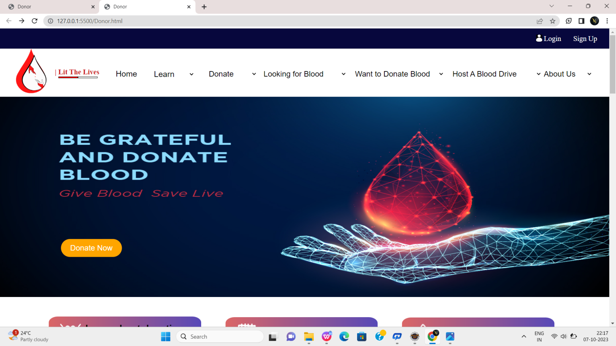

Fig:1

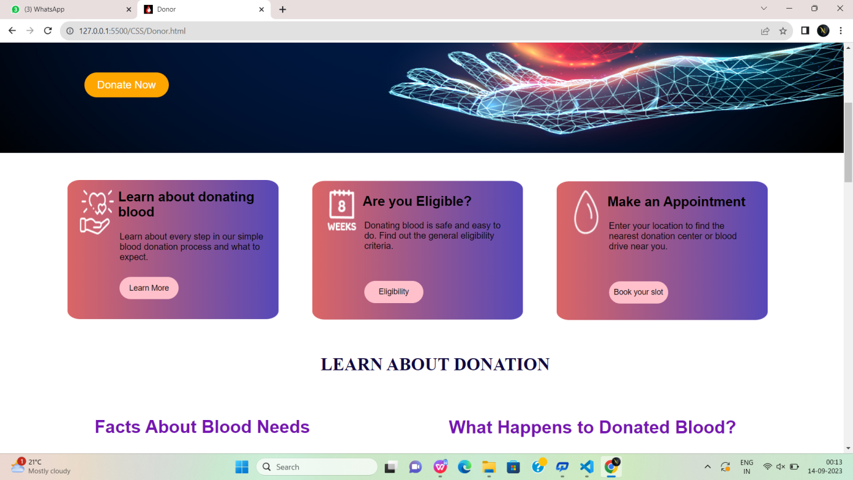

Fig:1.2

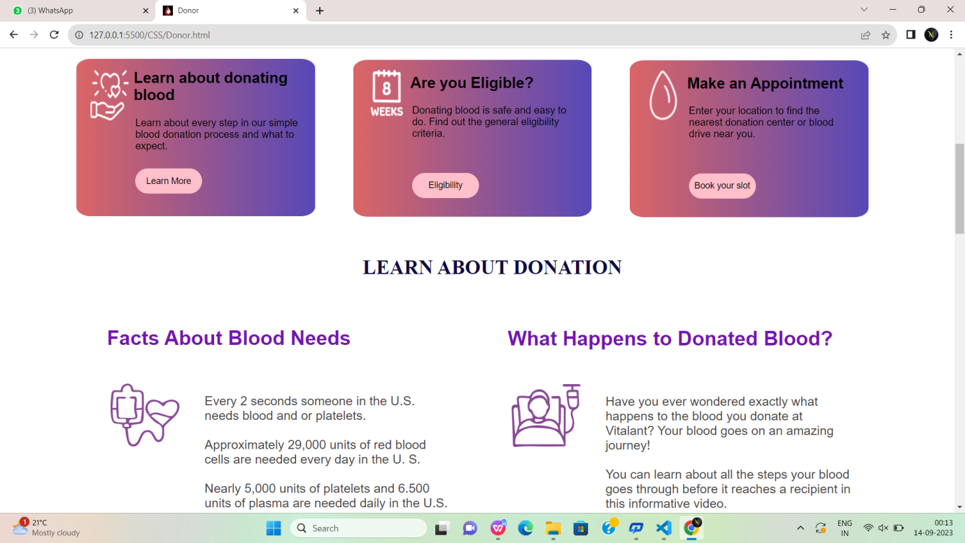

Fig:1.3

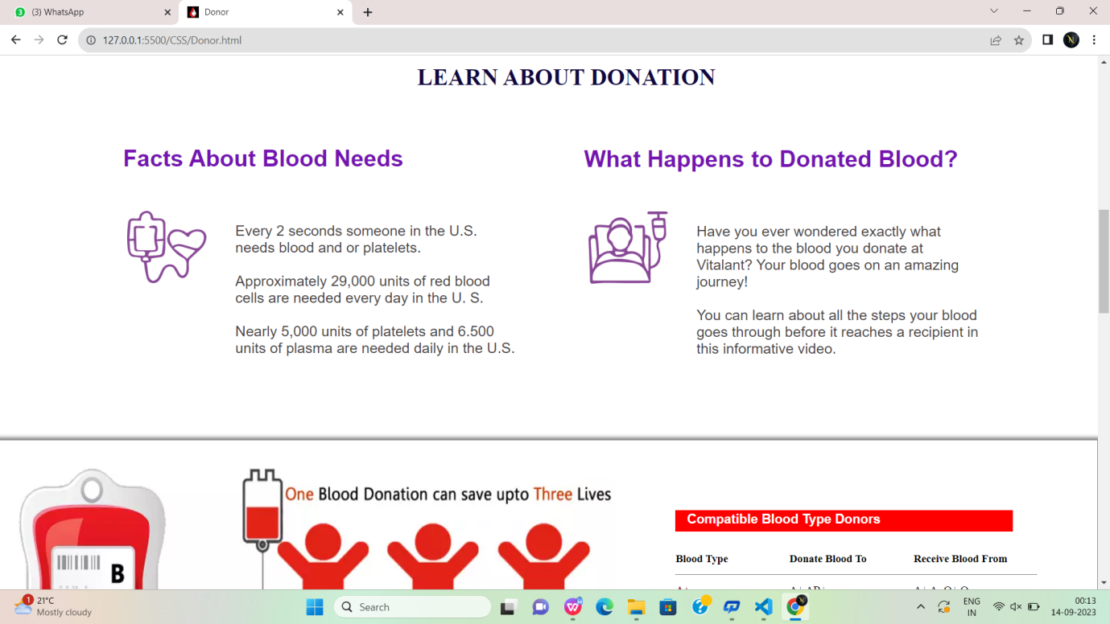

Fig:1.4

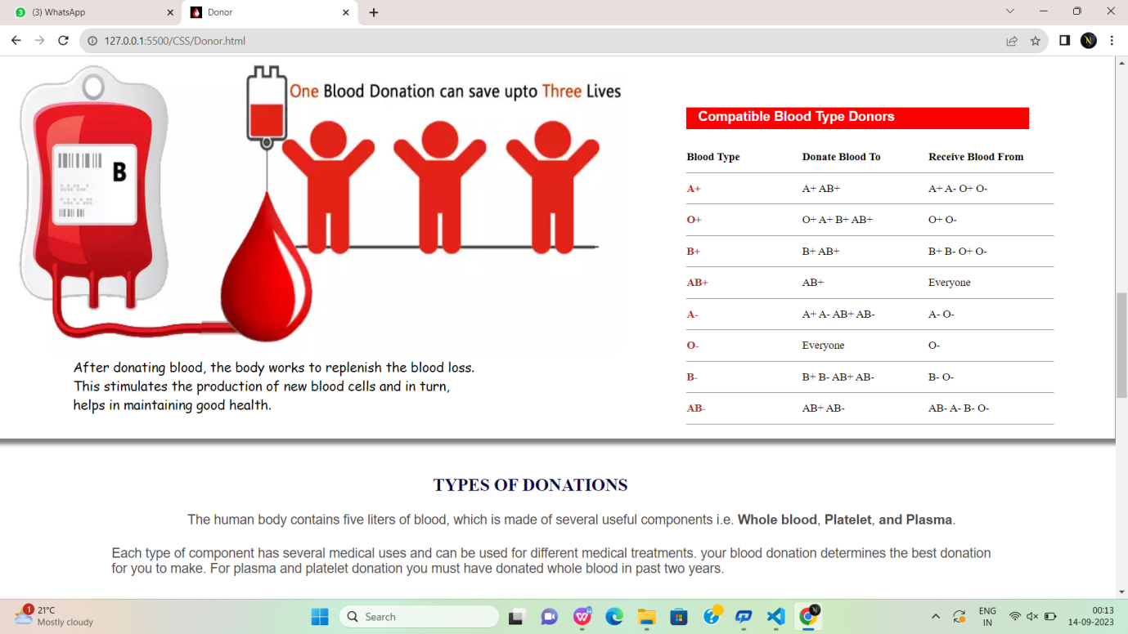

Fig:1.5

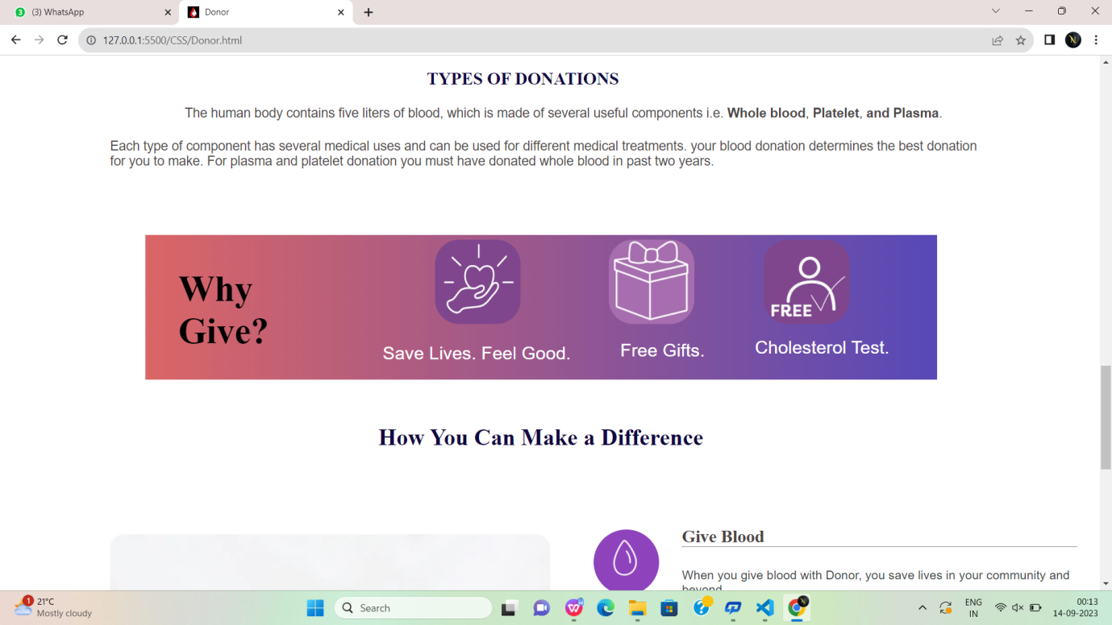

Fig:1.6

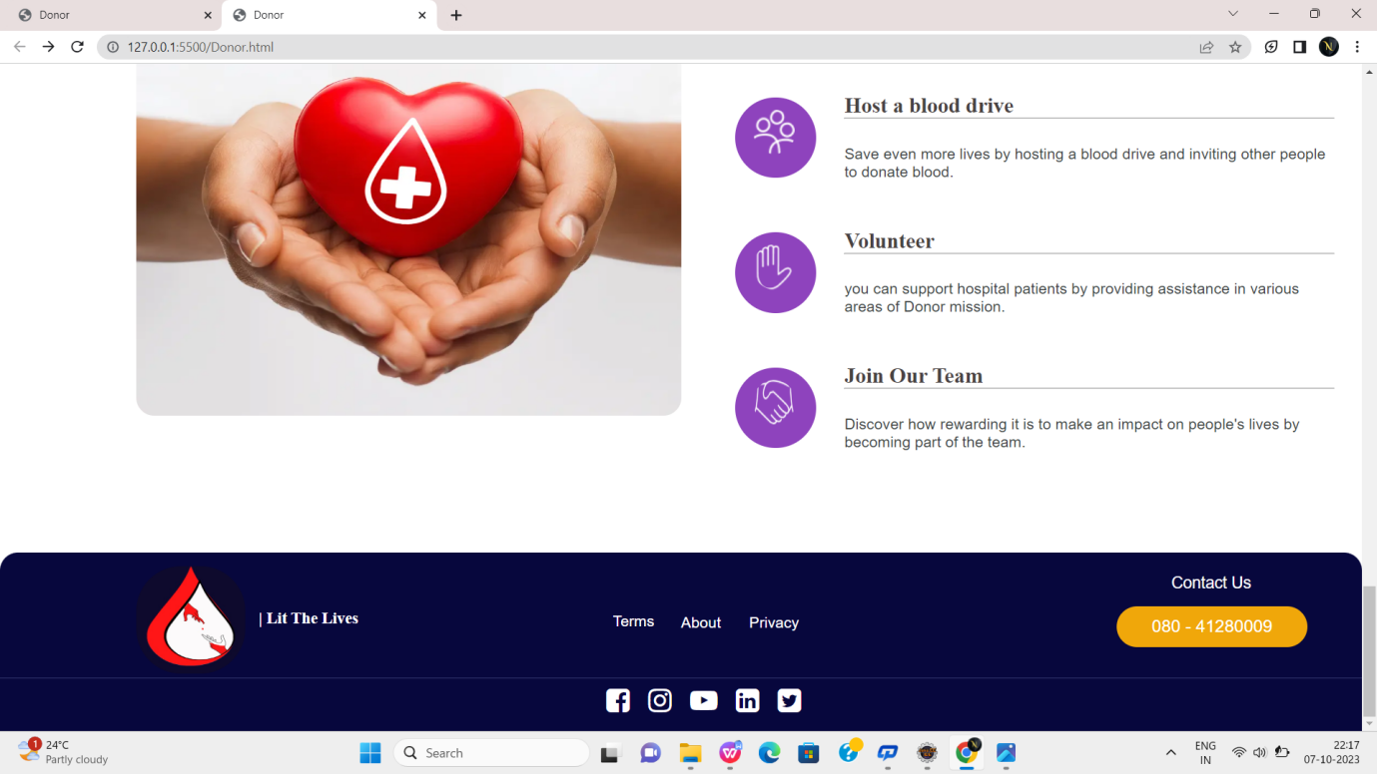

Fig:1.7

**Login.html:**

<!DOCTYPE html>

<html lang="en">

<head>

<meta charset="UTF-8">

<meta name="viewport" content="width=device-width, initial-scale=1.0">

<title>Document</title>

<style>

.no-outline:focus {

outline: none;

}

</style>

</head>

<body style="Background-image:linear-gradient(90deg,rgba(255,0,0,0.4),rgba(0, 94, 255, 0.3),gray),url('bb.jpeg.jpeg');background-size:cover;">

<form action="">

<div style="width:45%;height:400px;float: left;margin-top:-5px;margin-left: 800px;border-radius: 20px;">

<div style="width:100%;height:150px;float: left;margin-top:1px;margin-left: 1px;border-radius: 20px;">

<p style="font-size: 20px;margin-top: 90px;margin-left: 1px;"><b>LOGIN</b></p><p style="margin-left:2px;margin-top: -10px;color: black;">Enter Your phone number to continue</p>

<label value=" PHONE NUMBER" style="font-size: 20px;margin-top: 90px;margin-left: 20px;"></label>

<input type="number" class="no-outline" placeholder="Enter Mobile Number" style="width:50%;height:40px;font-size: 20px;margin-top: 20px;margin-left: -20px;outline: none;background-color:white;border: none;color:black" required>

<hr style="width: 50%;margin-left: -1%;">

<button style="width:50%;height:50px;background-color: rgb(223, 96, 10);float: left;margin-top:50px;margin-left: 1px;outline: none;border: 2px solid rgb(110, 50, 9);"><a href="Donor.html" style="text-decoration: none;color:aliceblue ;text-align: center;">Continue</a> </button>

<p style="font-size: 20px;margin-top: 120px;margin-left: 2px;font-size: 16px;width:50%">By clicking, I accept the Terms & conditions & Privacy Pilicy</p>

</div>

</form>

</body>

</html>

**Output:**

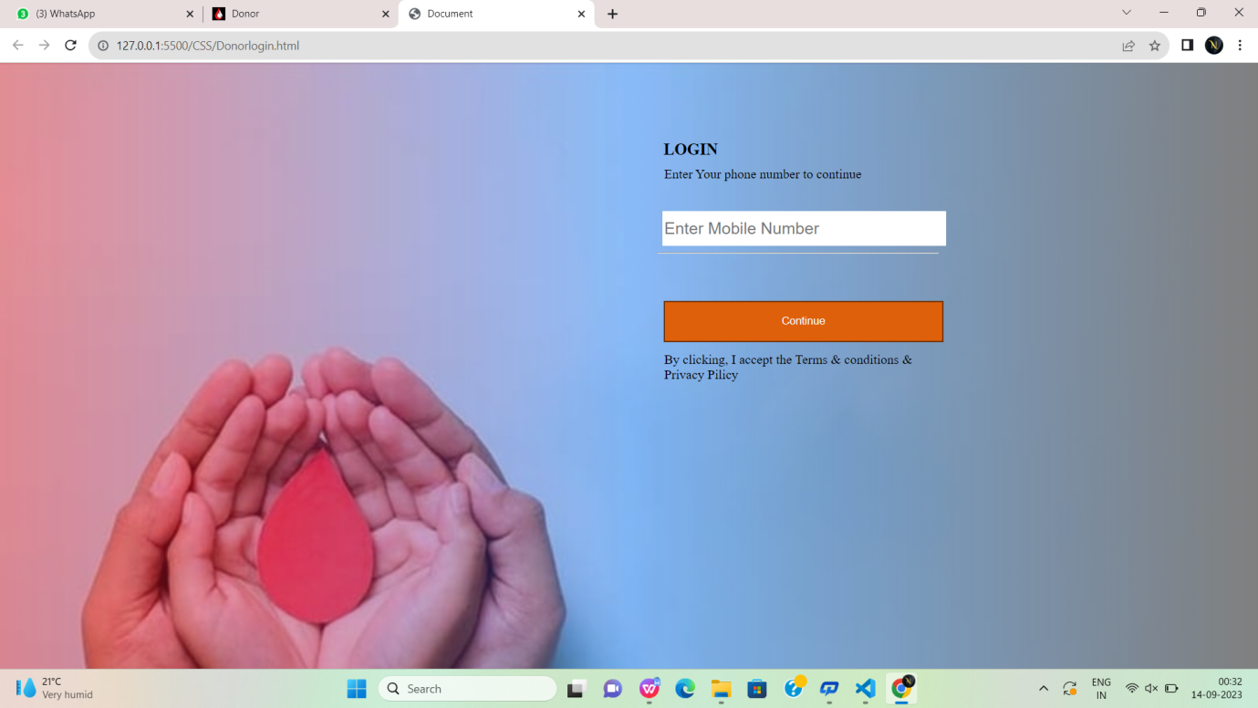

Fig:2

**SignUp.html:**

<!DOCTYPE html>

<html lang="en">

<head>

<meta charset="UTF-8">

<meta name="viewport" content="width=device-width, initial-scale=1.0">

<title>Document</title>

<style>

* {

margin: 0;

box-sizing: border-box;

font-family: sans-serif;

}

</style>

</style>

</head>

<body

style="Background-image:linear-gradient(90deg,rgba(0, 200, 255, 0.4),rgba(0, 94, 255, 0.3),gray);background-size:cover;">

<marquee direction="left" Style="margin-top: 4%;color:blue">|DONOR(LITE THE LIVES)</marquee>

<div

style="width:45%;height:500px;float: left;margin-top:6%;margin-left: 26%;border-radius: 20px;border: 1px solid rgb(240, 233, 233);background-color: white;">

<form action="">

<div style="width:100%;height:150px;float: left;margin-top:1px;margin-left: 25%;border-radius: 20px;">

<p style="font-size: 20px;margin-top: 90px;margin-left: 16%;"><b>SIGN UP</b></p>

<p style="margin-left:2px;margin-top: 10px;color: black;">Enter Your email address to continue</p>

<label value="" style="font-size: 20px;margin-top: 90px;margin-left: 20px;"></label>

<input type="email" class="no-outline" placeholder="Enter Email Id"

style="width:50%;height:40px;font-size: 18px;margin-top: 20px;margin-left: -20px;outline: none;background-color:white;border:none;color:black;border-radius: 5px;"

required>

<hr style="width: 50%;margin-left: 0.1%;margin-top: 2%;">

<label value="" style="font-size: 20px;margin-top: 90px;margin-left: 30%;"></label>

<input type="password" class="no-outline" placeholder="Enter your password"

style="width:50%;height:40px;font-size: 18px;margin-top: 20px;margin-left: -30%;outline: none;background-color:white;border:none;color:black;border-radius: 5px;"

required>

<hr style="width: 50%;margin-left: 0.1%;margin-top: 2%;">

<label value="" style="font-size: 20px;margin-top: 90px;margin-left: 30%;"></label>

<input type="password" class="no-outline" placeholder="Confirm your password"

style="width:50%;height:40px;font-size: 18px;margin-top: 20px;margin-left: -30%;outline: none;background-color:white;border:none;color:black;border-radius: 5px;"

required>

<hr style="width: 50%;margin-left: 0.1%;margin-top: 2%;">

<br><br><br>

<button

style="width:30%;height:50px;background-color: rgb(223, 96, 10);float: left;margin-top:-10px;margin-left: 9%;border-radius: 5px;"><a

href="Registration.html"

style="text-decoration: none;color:aliceblue ;text-align: center;padding: 2px;margin-top: -2%;">Continue</a>

</button>

</form>

</div>

</body>

</html>

**Output:**

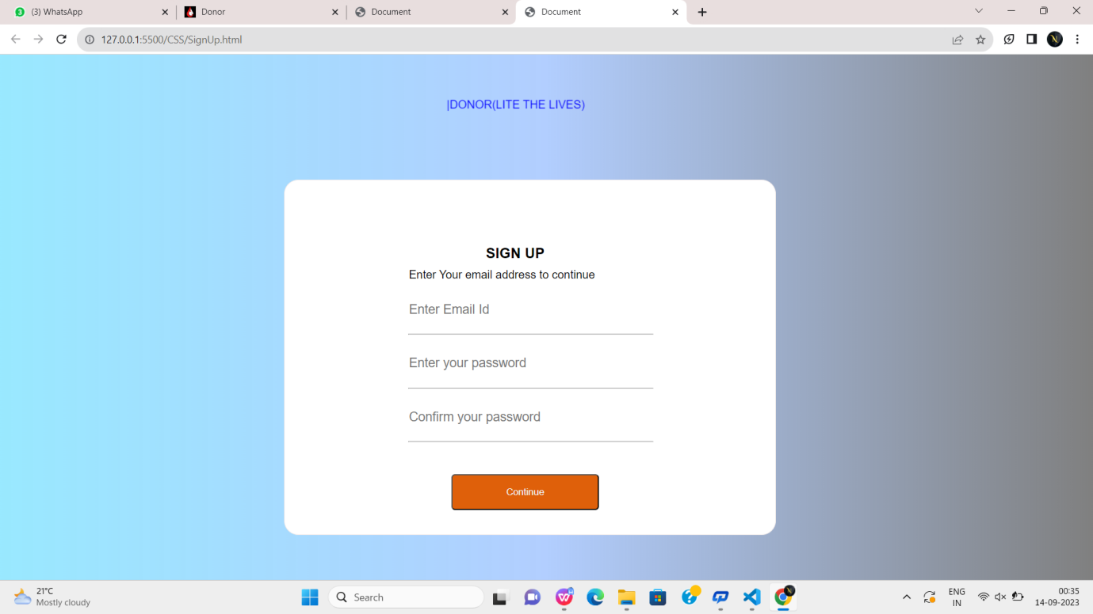

Fig:3

**Registration.html:**

<!DOCTYPE html>

<html lang="en">

<head>

<meta charset="UTF-8">

<meta name="viewport" content="width=device-width, initial-scale=1.0">

<title>Document</title>

<style>

*{

margin: 0;

box-sizing: border-box;

font-family: sans-serif;

}

</style>

</head>

<body>

<div style="background-color:rgb(203, 47, 78) ;height: 60px;border-radius: 10px;"><h1 style="color:white;margin-left: 40%;padding-top: 0.6%;">Register hear!</h1></div>

<div

style="width:45%;height:500px;float: left;margin-top:6%;margin-left: 26%;box-shadow: 2px 2px 2px 2px gray;border-radius: 20px;border: 1px solid rgb(161, 156, 156);background-color: white;">

<form action="">

<fieldset style="width:90%;margin-left:35px;border: none;">

<legend style="text-align: center;padding-top: 20px;font-family: sans-serif;"><b>REGISTRATION</b></legend><br>

<lable for="fname">First Name:</lable>&nbsp;&nbsp;&nbsp;&nbsp;&nbsp;&nbsp;&nbsp;&nbsp;&nbsp;&nbsp;&nbsp;

<input type="text" id="fname" placeholder="eg.Noshi" required style="height:30px; width:200px;font-family: sans-serif;" >&nbsp;&nbsp;&nbsp;&nbsp;&nbsp;&nbsp;

<br><br>

<lable for="lname">Last Name:</lable>&nbsp;&nbsp;&nbsp;&nbsp;&nbsp;&nbsp;&nbsp;&nbsp;&nbsp;&nbsp;&nbsp;

<input type="text" id="mname" style="height:30px; width:200px; font-family: sans-serif;">&nbsp;&nbsp;&nbsp;&nbsp;

<br><br>

<lable for="dob" >Date of Birth:</lable>&nbsp;&nbsp;&nbsp;&nbsp;&nbsp;&nbsp;&nbsp;&nbsp;

<input type="datetime-local" id="dob" style="height:30px; width:200px;font-family: sans-serif;">&nbsp;&nbsp;&nbsp;&nbsp;

<br><br>

<lable for="phno">Phone Number:</lable>&nbsp;&nbsp;&nbsp;&nbsp;

<input type="number" id="phno" style="height:30px; width:200px; font-family: sans-serif;">&nbsp;&nbsp;

<br><br>

<lable for="email">Email Id:</lable>&nbsp;&nbsp;&nbsp;&nbsp;&nbsp;&nbsp;&nbsp;&nbsp;&nbsp;&nbsp;&nbsp;&nbsp;&nbsp;&nbsp;&nbsp;

<input type="email" id="email" style="height:30px; width:200px; font-family: sans-serif;">&nbsp;&nbsp;

<br><br>

<lable for="gender" style="font-family: sans-serif;">Gender:</lable>&nbsp;&nbsp;&nbsp;&nbsp;&nbsp;&nbsp;&nbsp;&nbsp;&nbsp;&nbsp;&nbsp;&nbsp;&nbsp;&nbsp;&nbsp;&nbsp;

<input type="radio" id="gender" name="gender" value="MALE" >Male&nbsp;&nbsp;&nbsp;&nbsp;

<input type="radio" id="gender" name="gender" value="FEMALE">Female&nbsp;&nbsp;&nbsp;&nbsp;

<input type="radio" id="gender" name="gender" value="OTHERS">Others&nbsp;&nbsp;&nbsp;&nbsp;

<br><br>

<lable for="add" style="font-family: sans-serif;">Address:</lable>&nbsp;&nbsp;&nbsp;&nbsp;&nbsp;&nbsp;&nbsp;&nbsp;&nbsp;&nbsp;&nbsp;&nbsp;&nbsp;&nbsp;&nbsp;

<textarea name="" id="add" cols="40" rows="2"></textarea>

<br><br><br>

<lable for="gender" style="font-family: sans-serif;">Blood Group: </lable>&nbsp;&nbsp;&nbsp;&nbsp;&nbsp;&nbsp;&nbsp;

<input type="radio" id="gender" name="gender" value="">&nbsp;&nbsp;A+&nbsp;&nbsp;&nbsp;&nbsp;

<input type="radio" id="gender" name="gender" value="">&nbsp;&nbsp;AB+&nbsp;&nbsp;&nbsp;&nbsp;

<input type="radio" id="gender" name="gender" value="">&nbsp;&nbsp;AB-&nbsp;&nbsp;&nbsp;&nbsp;

<input type="radio" id="gender" name="gender" value="">&nbsp;&nbsp;O+&nbsp;&nbsp;&nbsp;&nbsp;

<input type="radio" id="gender" name="gender" value="">&nbsp;&nbsp;O-&nbsp;&nbsp;&nbsp;&nbsp;

<br><br><br>

</fieldset>

<center>

<a href="Donor.html" style="margin-left: 1.5%;position: absolute;margin-top: 0.7%;color:white;text-decoration: none;">SUBMIT</a><input style="text-align: center;background-color: rgb(203, 47, 78) ;color:white;width:15%;height: 40px;border: none;border-radius: 10px;" type="submit" value="">

<a href="Donor.html" style="margin-left: 1.5%;position: absolute;margin-top: 0.7%;color:white;text-decoration: none;">RESET</a><input style="text-align: center;background-color: rgb(203, 47, 78) ;color:white;width:15%;height: 40px;border: none;border-radius: 10px;" type="submit" value="">

</center>

</form>

</div>

</body>

</html>

**Output:**

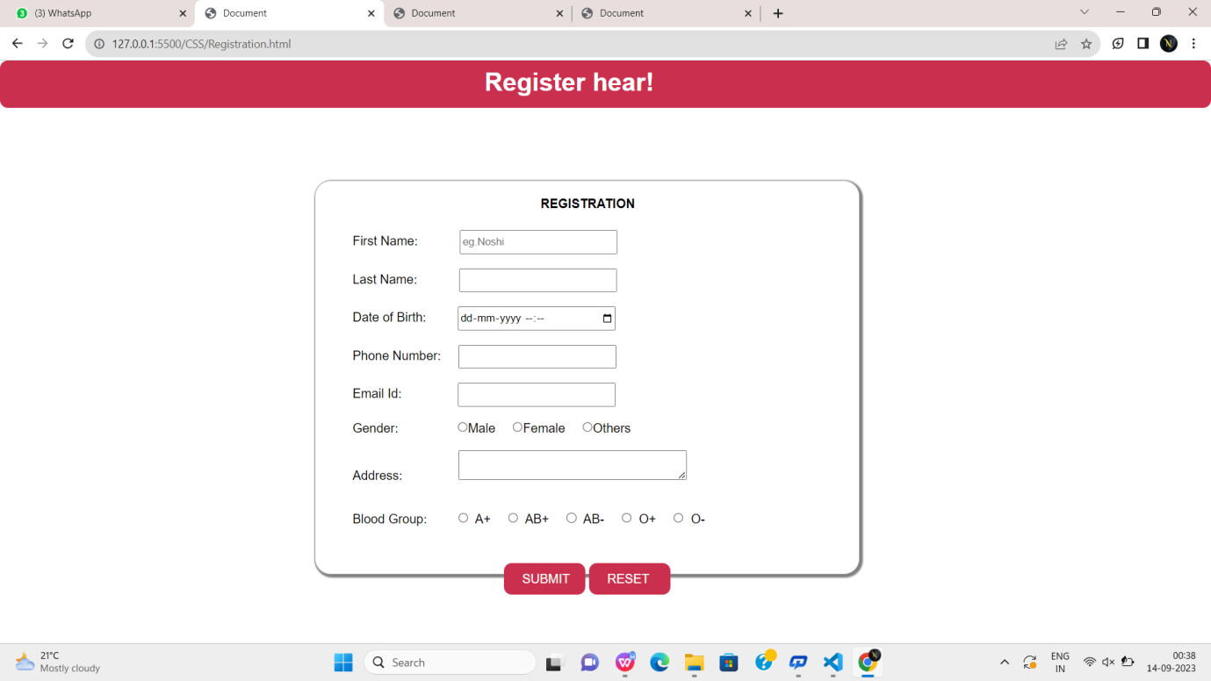

Fig:4

**Donatenow.html:**

<!DOCTYPE html>

<html lang="en">

<head>

<meta charset="UTF-8">

<meta name="viewport" content="width=device-width, initial-scale=1.0">

<title>Donor</title>

<link href="4.png" rel="icon">

<link rel="stylesheet" href="https://cdnjs.cloudflare.com/ajax/libs/font-awesome/4.7.0/css/font-awesome.min.css">

<link rel="stylesheet" href="Donor.css">

<style>

* {

margin: 0px;

box-sizing: border-box;

}

</style>

</head>

<body>

<div id="head">

<img id="icon"

src="https://encrypted-tbn0.gstatic.com/images?q=tbn:ANd9GcRES3iV003kCbG_MMRs4KglFDKAgl9GxdLAug&usqp=CAU"

alt="">

<a class="login" href="SignUp.html">Sign Up</a>

<a class="login" href="Donorlogin.html">Login</a>

</div>

<div id="head2">

<img src="donor1.png" alt="">

<p id="p"><b>| Lit The Lives</b></p>

<div id="line"></div>

<div id="line1"></div>

<div id="head3">

<a href="Donor.html"

style="text-decoration: none;font-size: 20px;font-family: sans-serif;color: black;margin-top: -1%;position: absolute;">

<p id="hom">Home</p>

</a>

<select name="" class="col2">

<option value="">Donate</option>

<option value="">Donate Blood</option>

<option value="">Health history questionnaire</option>

<option value="">Book an appointment</option>

<option value="">Locations</option>

</select>

<select name="" class="col1">

<option value="">Learn</option>

<option value="">Impacts of donation</option>

<option value="">Blood Groups</option>

<option value="">Donation Process</option>

<option value="">Scientific Research</option>

<option value="">Precautions</option>

</select>

<!-- <select name="" class="col2">

<option value="">Eligibility</option>

<option value="">Basic Requirements</option>

<option value="">Additional Information</option>

<option value="">Eligibity requirements</option>

</select> -->

<select name="" id="col4">

<option value="">Looking for Blood</option>

<option value="">Computer Science & Engineering</option>

<option value="">CSE - AI & ML</option>

<option value="">CSE - Data Sciencd</option>

<option value="">CSE - Cyber Security</option>

</select>

<select name="" id="col5">

<option value="">Want to Donate Blood</option>

<option value="">Blood Donation Camps</option>

<option value="">About Blood donation</option>

<option value="">Donor Registration</option>

<option value="">Login </option>

</select>

<select name="" class="col5">

<option value="">Host A Blood Drive</option>

<option value="">Learn about hosting</option>

<option value="">Apply to host a blood drive</option>

<option value="">Manage your blood drive</option>

</select>

<select name="" id="col2">

<option value="">About Us</option>

<option value="">Learn More</option>

<option value="">Why Blood donation</option>

</select>

</div>

</div>

<div

style="width:102%;height: 750px;border: none;margin-left: -2%;margin-top: 0%;background-image: linear-gradient(90deg,rgb(219, 102, 102),rgb(87, 73, 184));position: absolute;">

<div

style="width:45%;height:500px;float: left;margin-top:6%;margin-left: 29%;border-radius: 20px;border: 1px solid rgb(240, 233, 233);background-color: white;">

<form action="">

<div style="width:100%;height:150px;float: left;margin-top:1px;margin-left: 25%;border-radius: 20px;">

<p style="font-size: 20px;margin-top: 90px;margin-left: 0.4%;font-family: sans-serif;">Update your

location</p>

<p

style="margin-left:2px;margin-top: 25px;color: rgb(110, 5, 5);font-size: large;font-family: sans-serif;">

<b>First, please enter your address</b></p>

<label value="" style="font-size: 20px;margin-top: 90px;margin-left: 20px;"></label>

<input type="text" placeholder="Enter your location"

style="width:50%;height:40px;font-size: 18px;margin-top: 20px;margin-left: -20px;outline: none;background-color:white;border:1px solid gray;color:black;border-radius: 5px;"

required>

<br>

<a href="Donor.html"

style="text-decoration: none;color:white;text-align: center;margin-top: 5.5%;font-size: 15px;position: absolute;margin-left: -208px;">Set

Location</a>

<button

style="width:50%;height:50px;background-color: rgb(223, 96, 10);float: left;margin-top:70px;margin-left: 0%;border-radius: 50px;">

</button>

<p

style="font-size: 20px;margin-top: 140px;margin-left: 2px;font-size: 15px;font-family: sans-serif;">

By clicking, I accept the Terms & conditions & Privacy Pilicy</p>

</div>

</form>

<div

style="width: 223%;height: 200px;background-color: rgb(7, 7, 61);margin-top: 90%;margin-left: -65%;border-radius: 20px 20px 0px 0px ;">

<img style="margin-left: 10%;margin-top: 1%;border-radius: 50px;width:8%" src="bluelogo.jpeg" alt="">

<p id="p1"><b>| Lit The Lives</b></p>

<p style="margin-left: 86%;color:white;margin-top: -4%;font-family: sans-serif;font-size: large;">Contact Us

</p>

<a href="#"><input id="db" type="button" value="080 - 41280009"></a>

<a href="" style="margin-left: 45%;margin-top: 1.5%;position: absolute;color:white;text-decoration: none;font-family: sans-serif;font-size: 17px;">Terms</a>

<a href="" style="margin-left: 50%;margin-top: 1.6%;position: absolute;color:white;text-decoration: none;font-family: sans-serif;font-size: 17px;">About</a>

<a href="" style="margin-left: 55%;margin-top: 1.6%;position: absolute;color:white;text-decoration: none;font-family: sans-serif;font-size: 17px;">Privacy</a>

</div>

<hr style="margin-top: -9%;width:250%;margin-left: -92%;border:1px solid rgb(31, 33, 88)">

<div style="width:70%;height: 30px;margin-left: 28%;margin-top: 20px;">

<a class="icons" href="https://www.facebook.com/GlobalQuestTech"> <i class="fa fa-facebook-square"

style="font-size:30px;color:white;"></i></a>

<a class="icons" href="https://www.instagram.com/svcolleges/"> <i class="fa fa-instagram"

style="font-size:30px;color:white;margin-left: -5%;"></i></a>

<a class="icons"

href="https://www.linkedin.com/school/sri-venkateswara-college-of-engineering-tirupati/"> <i

class="fa fa-youtube-play" style="font-size:30px;color:white;margin-left: -5%;"></i></a>

<a class="icons"

href="https://www.linkedin.com/school/sri-venkateswara-college-of-engineering-tirupati/"><i

class="fa fa-linkedin-square" style="font-size:30px;color:white;margin-left: -5%;"></i></a>

<a class="icons" href="https://twitter.com/i/flow/login?redirect_after_login=%2FSVCE_Tirupati"><i

class="fa fa-twitter-square" style="font-size:30px;color:white;margin-left: -5%;"></i> </a>

</div>

</body>

</html>

**Output:**

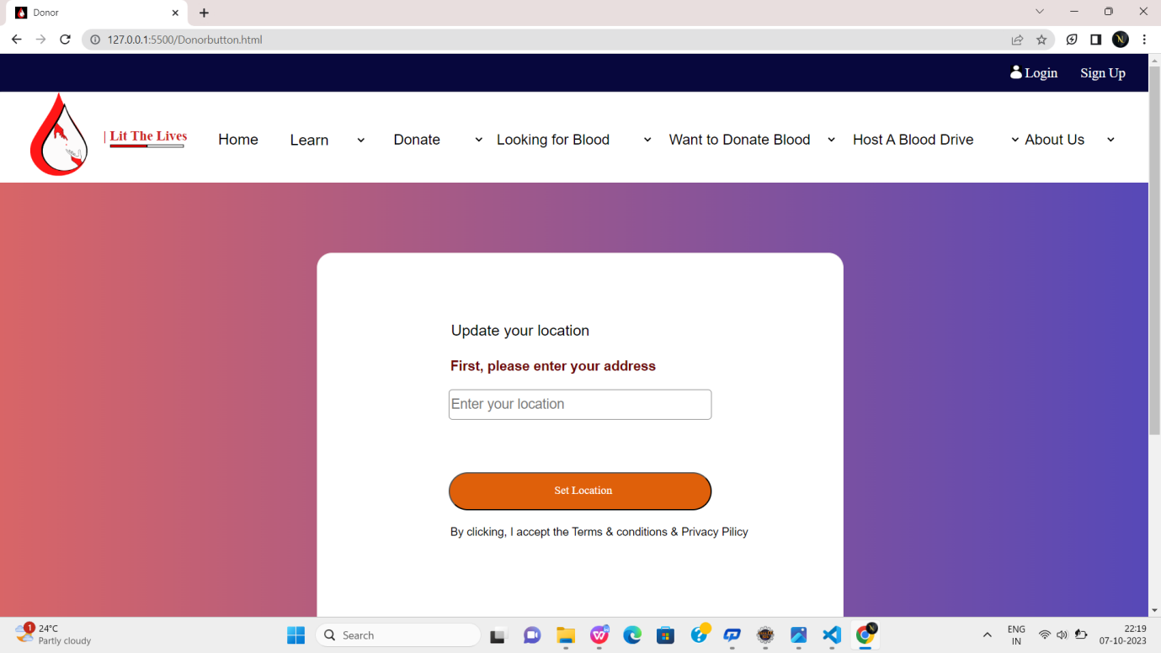

Fig:5

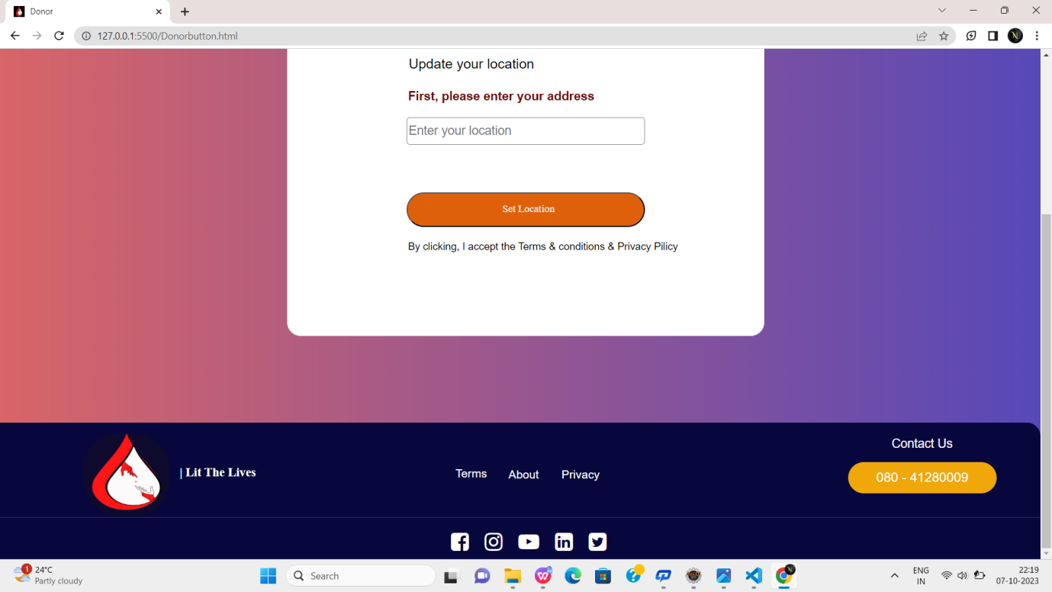

Fig:5.1

**Eligibility.html:**

<!DOCTYPE html>

<html lang="en">

<head>

<meta charset="UTF-8">

<meta name="viewport" content="width=device-width, initial-scale=1.0">

<title>Donor</title>

<link href="4.png" rel="icon">

<link rel="stylesheet" href="https://cdnjs.cloudflare.com/ajax/libs/font-awesome/4.7.0/css/font-awesome.min.css">

<link rel="stylesheet" href="Donor.css">

<style>

* {

margin: 0px;

box-sizing: border-box;

}

</style>

</head>

<body>

<div id="head">

<img id="icon"

src="https://encrypted-tbn0.gstatic.com/images?q=tbn:ANd9GcRES3iV003kCbG_MMRs4KglFDKAgl9GxdLAug&usqp=CAU"

alt="">

<a class="login" href="SignUp.html">Sign Up</a>

<a class="login" href="Donorlogin.html">Login</a>

</div>

<div id="head2">

<img src="donor1.png" alt="">

<p id="p"><b>| Lit The Lives</b></p>

<div id="line"></div>

<div id="line1"></div>

<div id="head3">

<a href="Donor.html"

style="text-decoration: none;font-size: 20px;font-family: sans-serif;color: black;margin-top: -1%;position: absolute;">

<p id="hom">Home</p>

</a>

<select name="" class="col2">

<option value="">Donate</option>

<option value="">Donate Blood</option>

<option value="">Health history questionnaire</option>

<option value="">Book an appointment</option>

<option value="">Locations</option>

</select>

<select name="" class="col1">

<option value="">Learn</option>

<option value="">Impacts of donation</option>

<option value="">Blood Groups</option>

<option value="">Donation Process</option>

<option value="">Scientific Research</option>

<option value="">Precautions</option>

</select>

<!-- <select name="" class="col2">

<option value="">Eligibility</option>

<option value="">Basic Requirements</option>

<option value="">Additional Information</option>

<option value="">Eligibity requirements</option>

</select> -->

<select name="" id="col4">

<option value="">Looking for Blood</option>

<option value="">Computer Science & Engineering</option>

<option value="">CSE - AI & ML</option>

<option value="">CSE - Data Sciencd</option>

<option value="">CSE - Cyber Security</option>

</select>

<select name="" id="col5">

<option value="">Want to Donate Blood</option>

<option value="">Blood Donation Camps</option>

<option value="">About Blood donation</option>

<option value="">Donor Registration</option>

<option value="">Login </option>

</select>

<select name="" class="col5">

<option value="">Host A Blood Drive</option>

<option value="">Learn about hosting</option>

<option value="">Apply to host a blood drive</option>

<option value="">Manage your blood drive</option>

</select>

<select name="" id="col2">

<option value="">About Us</option>

<option value="">Learn More</option>

<option value="">Why Blood donation</option>

</select>

</div>

</div>

<div style="width:80%;height: 800px;border:none;margin-left: 150px;margin-top: 50px;">

<h1 style="margin-left: 2%;font-family: sans-serif;color:rgb(99, 93, 93)"><b>Basic Eligibility Requirements for

Blood Donation</b></h1><br>

<p style="text-align: justify;font-family: sans-serif;font-size: 20px;padding: 30px;line-height: 30px;">You may

be wondering if you can donate blood. Donating blood is safe and easy to do, but there are a few basic

requirements to donate blood. If you're in good health and meet the general eligibility blood donation

requirements, then you are likely able to give blood. Please schedule your appointment today to transform

the lives of patients in need.<br><br>

Blood donors are needed every day to save lives. Recent changes by the FDA to eligibility guidance,

including the Individual Donor Assessment and European travel, may mean those once deferred can give. Please

review the additional eligibility information below if you have questions about health conditions, HIV risk,

medications, travel and more. If you don’t meet the blood donation requirements today or receive a deferral,

we encourage you to come back and try again. You will likely be eligible to donate blood in the

future.<br><br>

Why are there requirements to donate blood? Eligibility requirements are important to help ensure the safety

of both the blood donor and blood recipient. The Food and Drug Administration (FDA) has established blood

donation requirements to keep the blood supply safe from bloodborne diseases and also keep patients safe

from anything in a donor’s blood (such as a medication) that could harm them. These blood donation

requirements also protect donors by making sure they are physically able to safely donate.

<br><br>

<h1 style="margin-left: 2%;font-family: sans-serif;color:rgb(99, 93, 93)"><b>Basic Eligibility Requirements for

Blood Donation</b></h1><br>

<ul type="disc" style="font-size: 20px;font-family: sans-serif;line-height: 30px;text-align: justify;">

<li>Must be at least 16 years old (16- and some 17-year-olds must bring a signed permission form from a

parent

or guardian, if required by state or school).</li>

<li> Weigh at least 110 pounds. Certain height/weight criteria may apply for donors 22 years old or younger.

For

specific requirements in your area, please call 877-258-4825.

Be in good general health.</li>

<li>For your safety and to ensure a positive donation experience, make sure you eat within two hours ahead

of

your donation. Drink plenty of water that day and 24 to 48 hours beforehand. Feel free to help yourself

to

something to eat and drink in our refreshment area.</li>

<li>Bring your ID—something with your name and one of the following: date of birth, donor ID number or your

photo.</li>

<li> You must wait eight weeks between whole blood donations. Learn more about specific intervals for other

types

of donation.</li>

<li>You should not be under the influence of alcohol or recreational drugs at the time of donation.</li>

</ul><br><br>

<h1 style="margin-left: 2%;font-family: sans-serif;color:rgb(99, 93, 93)"><b>Additional requirements for

platelet and Power Red donation</b></h1><br>

<un type="disc" style="font-size: 20px;font-family: sans-serif;line-height: 30px;text-align: justify;">

<li>Platelet donors should avoid aspirin and/or aspirin-containing products 48 hours prior to donation and

other anti-platelet medications.</li>

<li>Power Red donors must meet certain height and weight requirements.</li>

</un>

</p>

</div>

<div

style="width: 100%;height: 200px;background-color: rgb(7, 7, 61);margin-top: 30%;margin-left: -0.1%;border-radius: 20px 20px 0px 0px ;">

<img style="margin-left: 10%;margin-top: 1%;border-radius: 50px;width:8%" src="bluelogo.jpeg" alt="">

<p id="p1"><b>| Lit The Lives</b></p>

<p style="margin-left: 86%;color:white;margin-top: -4%;font-family: sans-serif;font-size: large;">Contact Us

</p>

<a href="#"><input id="db" type="button" value="080 - 41280009"></a>

<a href=""

style="margin-left: 45%;margin-top: 1.5%;position: absolute;color:white;text-decoration: none;font-family: sans-serif;font-size: 17px;">Terms</a>

<a href=""

style="margin-left: 50%;margin-top: 1.6%;position: absolute;color:white;text-decoration: none;font-family: sans-serif;font-size: 17px;">About</a>

<a href=""

style="margin-left: 55%;margin-top: 1.6%;position: absolute;color:white;text-decoration: none;font-family: sans-serif;font-size: 17px;">Privacy</a>

</div>

<hr style="margin-top: -5%;width:100%;margin-left: -3%;border:1px solid rgb(31, 33, 88)">

<div style="width:30%;height: 30px;margin-left: 42%;margin-top: 14px;">

<a class="icons" href="https://www.facebook.com/GlobalQuestTech"> <i class="fa fa-facebook-square"

style="font-size:30px;color:white;"></i></a>

<a class="icons" href="https://www.instagram.com/svcolleges/"> <i class="fa fa-instagram"

style="font-size:30px;color:white;margin-left: -5%;"></i></a>

<a class="icons" href="https://www.linkedin.com/school/sri-venkateswara-college-of-engineering-tirupati/"> <i

class="fa fa-youtube-play" style="font-size:30px;color:white;margin-left: -5%;"></i></a>

<a class="icons" href="https://www.linkedin.com/school/sri-venkateswara-college-of-engineering-tirupati/"><i

class="fa fa-linkedin-square" style="font-size:30px;color:white;margin-left: -5%;"></i></a>

<a class="icons" href="https://twitter.com/i/flow/login?redirect_after_login=%2FSVCE_Tirupati"><i

class="fa fa-twitter-square" style="font-size:30px;color:white;margin-left: -5%;"></i> </a>

</div>

</body>

</html>

**Output:**

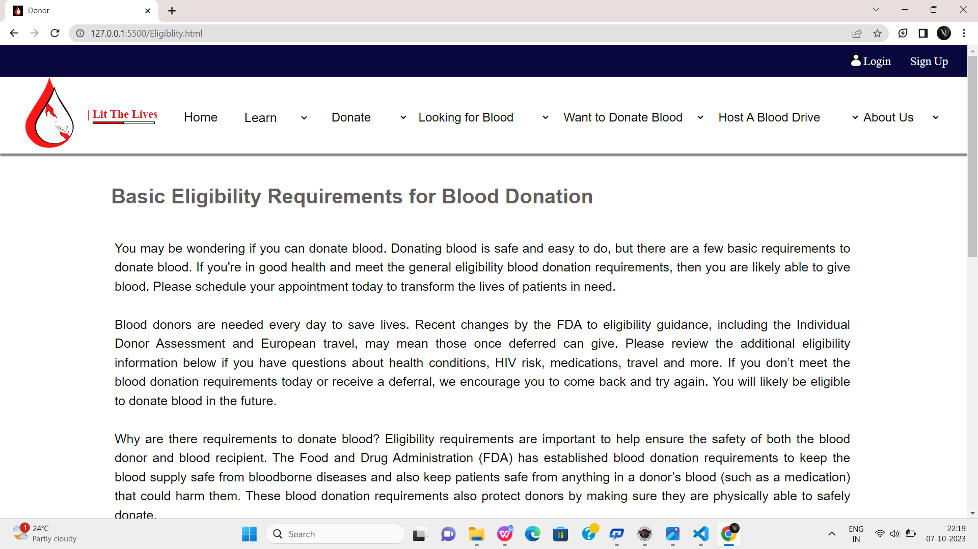

Fig:6

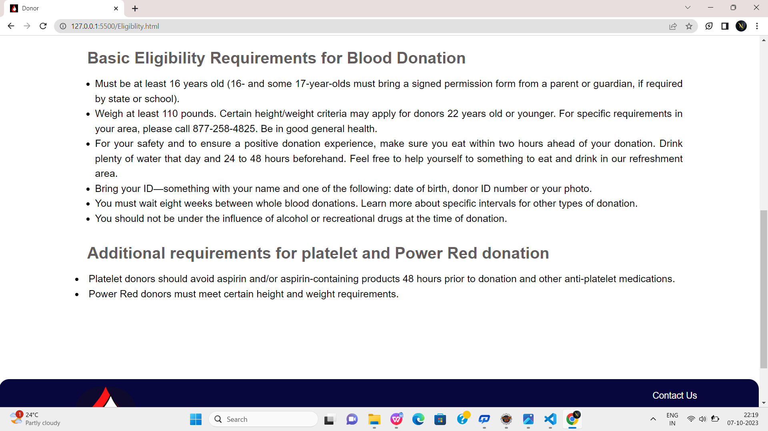

Fig 6.1

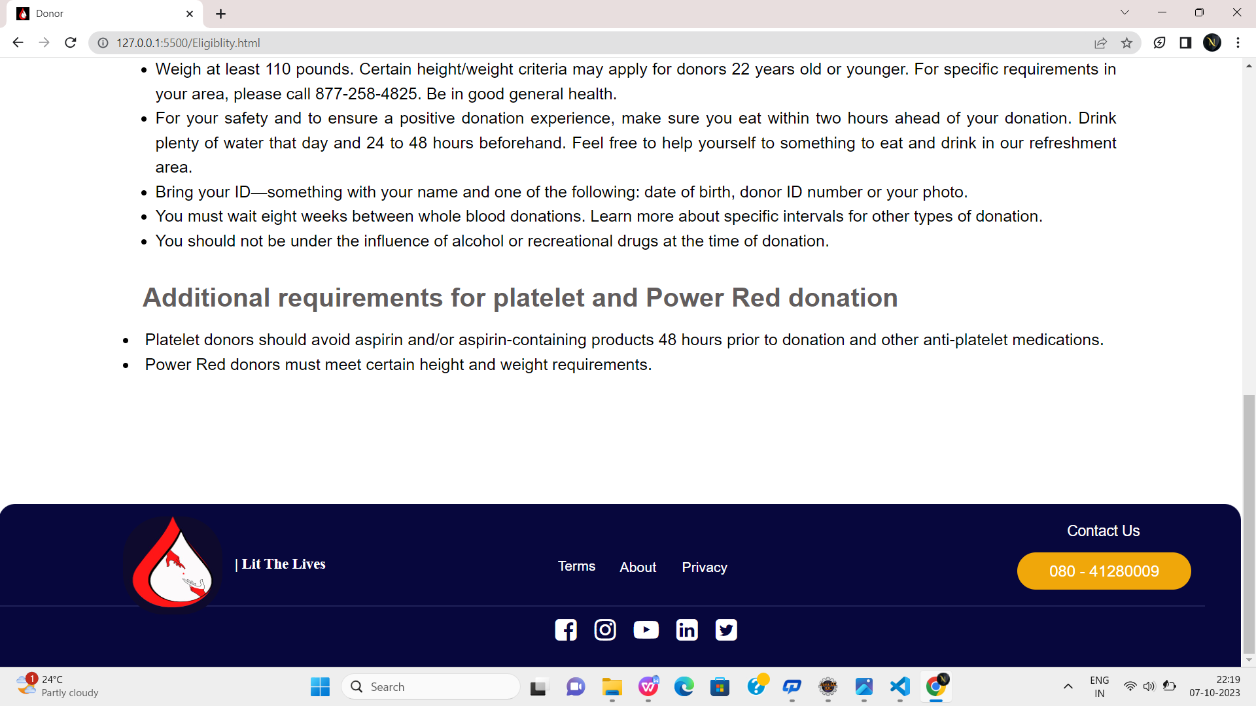

Fig 6.2

**Bookaslot.html:**

<!DOCTYPE html>

<html lang="en">

<head>

<meta charset="UTF-8">

<meta name="viewport" content="width=device-width, initial-scale=1.0">

<title>Donor</title>

<link href="4.png" rel="icon">

<link rel="stylesheet" href="https://cdnjs.cloudflare.com/ajax/libs/font-awesome/4.7.0/css/font-awesome.min.css">

<link rel="stylesheet" href="Donor.css">

<style>

* {

margin: 0px;

box-sizing: border-box;

}

</style>

</head>

<body>

<div id="head">

<img id="icon"

src="https://encrypted-tbn0.gstatic.com/images?q=tbn:ANd9GcRES3iV003kCbG_MMRs4KglFDKAgl9GxdLAug&usqp=CAU"

alt="">

<a class="login" href="SignUp.html">Sign Up</a>

<a class="login" href="Donorlogin.html">Login</a>

</div>

<div id="head2">

<img src="donor1.png" alt="">

<p id="p"><b>| Lit The Lives</b></p>

<div id="line"></div>

<div id="line1"></div>

<div id="head3">

<a href="Donor.html"

style="text-decoration: none;font-size: 20px;font-family: sans-serif;color: black;margin-top: -1%;position: absolute;">

<p id="hom">Home</p>

</a>

<select name="" class="col2">

<option value="">Donate</option>

<option value="">Donate Blood</option>

<option value="">Health history questionnaire</option>

<option value="">Book an appointment</option>

<option value="">Locations</option>

</select>

<select name="" class="col1">

<option value="">Learn</option>

<option value="">Impacts of donation</option>

<option value="">Blood Groups</option>

<option value="">Donation Process</option>

<option value="">Scientific Research</option>

<option value="">Precautions</option>

</select>

<!-- <select name="" class="col2">

<option value="">Eligibility</option>

<option value="">Basic Requirements</option>

<option value="">Additional Information</option>

<option value="">Eligibity requirements</option>

</select> -->

<select name="" id="col4">

<option value="">Looking for Blood</option>

<option value="">Computer Science & Engineering</option>

<option value="">CSE - AI & ML</option>

<option value="">CSE - Data Sciencd</option>

<option value="">CSE - Cyber Security</option>

</select>

<select name="" id="col5">

<option value="">Want to Donate Blood</option>

<option value="">Blood Donation Camps</option>

<option value="">About Blood donation</option>

<option value="">Donor Registration</option>

<option value="">Login </option>

</select>

<select name="" class="col5">

<option value="">Host A Blood Drive</option>

<option value="">Learn about hosting</option>

<option value="">Apply to host a blood drive</option>

<option value="">Manage your blood drive</option>

</select>

<select name="" id="col2">

<option value="">About Us</option>

<option value="">Learn More</option>

<option value="">Why Blood donation</option>

</select>

</div>

</div>

<div

style="width:102%;height: 700px;border: none;margin-left: -2%;margin-top: 0.2%;background-image: linear-gradient(90deg,rgb(219, 102, 102),rgb(87, 73, 184));">

<form action="">

<fieldset style="width:30%;margin-left: 35%;border: none;">

<legend style="text-align: center;padding-top: 20px;font-family: sans-serif;"><b>Book A Sloat</b></legend><br>

<lable for="fname" style="color: white;font-family: sans-serif;">First Name:</lable>&nbsp;&nbsp;&nbsp;&nbsp;&nbsp;&nbsp;&nbsp;&nbsp;&nbsp;&nbsp;&nbsp;

<input type="text" id="fname" placeholder="eg.Navya" required style="height:30px; width:200px;font-family: sans-serif;" >&nbsp;&nbsp;&nbsp;&nbsp;&nbsp;&nbsp;

<br><br>

<lable for="lname" style="color: white;font-family: sans-serif;">Last Name:</lable>&nbsp;&nbsp;&nbsp;&nbsp;&nbsp;&nbsp;&nbsp;&nbsp;&nbsp;&nbsp;&nbsp;

<input type="text" id="mname" style="height:30px; width:200px; font-family: sans-serif;">&nbsp;&nbsp;&nbsp;&nbsp;

<br><br>

<lable for="dob" style="color: white;font-family: sans-serif;">Date of Birth:</lable>&nbsp;&nbsp;&nbsp;&nbsp;&nbsp;&nbsp;&nbsp;&nbsp;

<input type="datetime-local" id="dob" style="height:30px; width:200px;font-family: sans-serif;">&nbsp;&nbsp;&nbsp;&nbsp;

<br><br>

<lable for="phno" style="color: white;font-family: sans-serif;">Phone Number:</lable>&nbsp;&nbsp;&nbsp;&nbsp;

<input type="number" id="phno" style="height:30px; width:200px; font-family: sans-serif;">&nbsp;&nbsp;

<br><br>

<lable for="gender" style="font-family: sans-serif;color: white;">Gender:</lable>&nbsp;&nbsp;&nbsp;&nbsp;&nbsp;&nbsp;&nbsp;&nbsp;&nbsp;&nbsp;&nbsp;&nbsp;&nbsp;&nbsp;&nbsp;&nbsp;

<input type="radio" id="gender" name="gender" value="MALE" >Male&nbsp;&nbsp;&nbsp;&nbsp;

<input type="radio" id="gender" name="gender" value="FEMALE">Female&nbsp;&nbsp;&nbsp;&nbsp;

<input type="radio" id="gender" name="gender" value="OTHERS">Others&nbsp;&nbsp;&nbsp;&nbsp;

<br><br>

<lable for="add" style="font-family: sans-serif;color:white">Location:</lable>&nbsp;&nbsp;&nbsp;&nbsp;&nbsp;&nbsp;&nbsp;&nbsp;&nbsp;&nbsp;&nbsp;&nbsp;&nbsp;&nbsp;&nbsp;

<textarea name="" id="add" cols="24" rows="2"></textarea>

<br><br><br>

<lable for="gender" style="font-family: sans-serif;color:white">Blood Group: </lable>&nbsp;&nbsp;&nbsp;&nbsp;&nbsp;&nbsp;&nbsp;

<input type="radio" id="gender" name="gender" value="">&nbsp;A+&nbsp;&nbsp;&nbsp;&nbsp;

<input type="radio" id="gender" name="gender" value="">&nbsp;AB+&nbsp;&nbsp;&nbsp;&nbsp;

<input type="radio" id="gender" name="gender" value="">&nbsp;AB-&nbsp;&nbsp;&nbsp;&nbsp;

<input type="radio" id="gender" name="gender" value="">&nbsp;O+&nbsp;&nbsp;&nbsp;&nbsp;

<input type="radio" id="gender" name="gender" value="">&nbsp;O-&nbsp;&nbsp;&nbsp;&nbsp;

<br><br><br>

<lable for="phno"style="color: white;font-family: sans-serif;">Date & Time:</lable>&nbsp;&nbsp;&nbsp;&nbsp;&nbsp;&nbsp;&nbsp;&nbsp;

<input type="datetime" id="phno" style="height:30px; width:200px; font-family: sans-serif;">&nbsp;&nbsp;

<br><br>

</fieldset>

<center>

<a href="Donor.html"><input style="text-align: center;background-color: rgb(203, 47, 78) ;color:white;width:15%;height: 40px;border: none;border-radius: 10px;" type="submit" value="BOOK NOW"></a>

<a href="Donor.html"><input style="text-align: center;background-color: rgb(203, 47, 78) ;color:white;width:15%;height: 40px;border: none;border-radius: 10px;" type="reset" value="RESET"></a>

</center>

</form>

<div

style="width: 100%;height: 200px;background-color: rgb(7, 7, 61);margin-top: 10%;margin-left: -0.1%;border-radius: 20px 20px 0px 0px ;">

<img style="margin-left: 10%;margin-top: 0.5%;border-radius: 50px;width:8%" src="bluelogo.jpeg" alt="">

<p id="p1"><b>| Lit The Lives</b></p>

<p style="margin-left: 84%;color:white;margin-top: -4%;font-family: sans-serif;font-size: large;">Contact Us

</p>

<a href="#"><input id="db" type="button" value="080 - 41280009"></a>

<a href=""

style="margin-left: 45%;margin-top: 1.5%;position: absolute;color:white;text-decoration: none;font-family: sans-serif;font-size: 17px;">Terms</a>

<a href=""

style="margin-left: 50%;margin-top: 1.6%;position: absolute;color:white;text-decoration: none;font-family: sans-serif;font-size: 17px;">About</a>

<a href=""

style="margin-left: 55%;margin-top: 1.6%;position: absolute;color:white;text-decoration: none;font-family: sans-serif;font-size: 17px;">Privacy</a>

</div>

<hr style="margin-top: -5%;width:100%;margin-left: -1%;border:1px solid rgb(31, 33, 88)">

<div style="width:30%;height: 30px;margin-left: 41%;margin-top: 14px;">

<a class="icons" href="https://www.facebook.com/GlobalQuestTech"> <i class="fa fa-facebook-square"

style="font-size:30px;color:white;"></i></a>

<a class="icons" href="https://www.instagram.com/svcolleges/"> <i class="fa fa-instagram"

style="font-size:30px;color:white;margin-left: -5%;"></i></a>

<a class="icons" href="https://www.linkedin.com/school/sri-venkateswara-college-of-engineering-tirupati/"> <i

class="fa fa-youtube-play" style="font-size:30px;color:white;margin-left: -5%;"></i></a>

<a class="icons" href="https://www.linkedin.com/school/sri-venkateswara-college-of-engineering-tirupati/"><i

class="fa fa-linkedin-square" style="font-size:30px;color:white;margin-left: -5%;"></i></a>

<a class="icons" href="https://twitter.com/i/flow/login?redirect_after_login=%2FSVCE_Tirupati"><i

class="fa fa-twitter-square" style="font-size:30px;color:white;margin-left: -5%;"></i> </a>

</div>

</body>

</html>

**Output:**

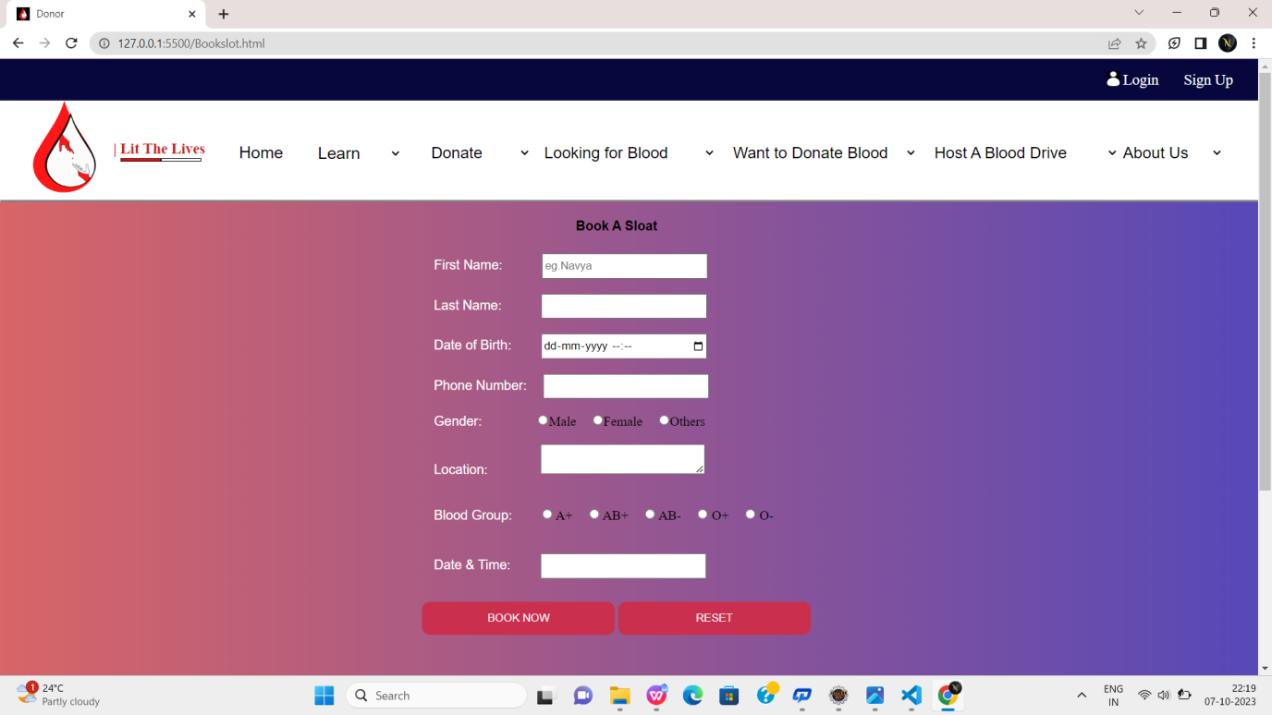

Fig 7

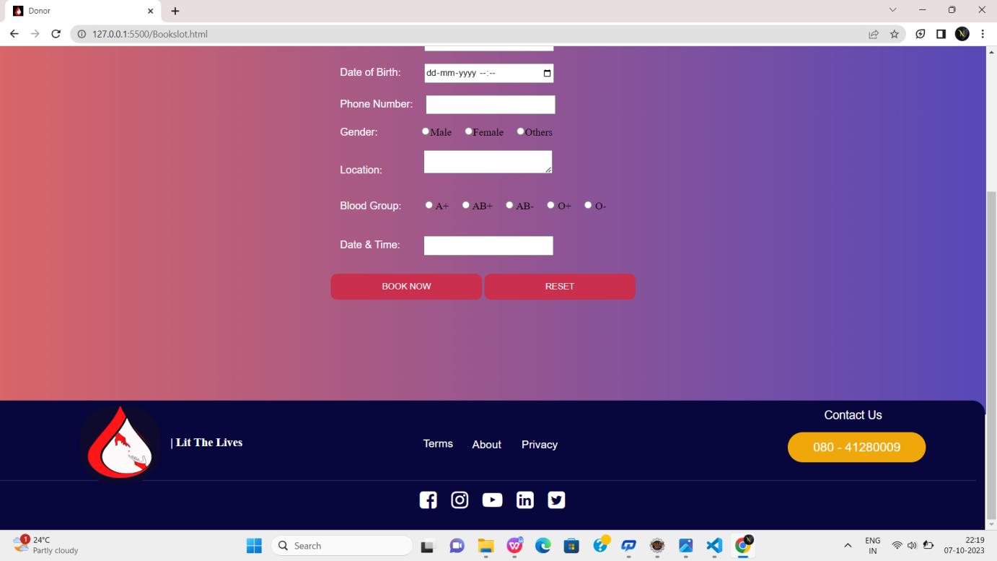

Fig 7.1

**Conclusion**

A blood donor website has the potential to save lives and play a crucial role in healthcare. Its scope encompasses user registration, matching donors and recipients, managing donor information, ensuring privacy and security, and fostering a sense of community. Collaboration with healthcare professionals, adherence to legal standards, and continuous improvement are essential for its success. By providing a platform that connects donors with recipients efficiently and reliably, a blood donor website can make a significant impact on healthcare and emergency response systems.